**IELTS LISTENING**

At first, we need to understand about the IELTS listening exam pattern. It comprises of 4 parts:

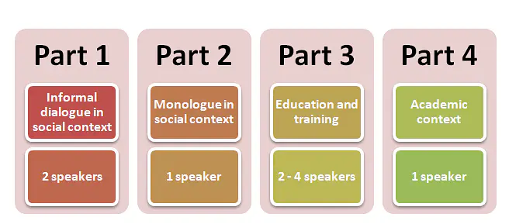

The total test time allotted is 40 minutes:-

* 30 minutes of listening
* 10 minutes to write down your answers from the test sheet onto the answer sheet.

**NOTE:-** There is no requirement to go through any subject specifically. All the answers you need will be provided in the recording itself.

**IELTS Listening Tips**

Let's start learning about the IELTS listening tips for band 9 with the mandatory points. There are 4 fundamental IELTS listening test tips that every candidate needs to focus on.

**Grammar**

Incorrect grammar will have a negative marking. So, be very careful with things like plural nouns, singular nouns, tenses, verbs. For example, the names of countries, cities must be in Capital letters.

**Spelling**

Incorrect spelling will be marked as a wrong answer. So, you have to be very careful while writing the answers.

**Handwriting**

Only visibly acceptable handwriting is accepted, therefore ensure that your handwriting is proper.

**Use all capitals**

If you think you will mess it up while rushing to catch up time then it is better to write your answers in CAPITALS. In that case, you will not lose marks.

### Focus on 3 Components of IELTS Listening

The IELTS listening tips and tricks academic includes 3 main rules of active listening which should be focused on:

1. **Comprehend**: Test-takers should concentrate on both the verbal and non-verbal expressions of the speaker to interpret what they are intending to say;
2. **Retain**: Test-takers tend to note down the vital key points to ensure accurate answers later on;
3. **Respond**.